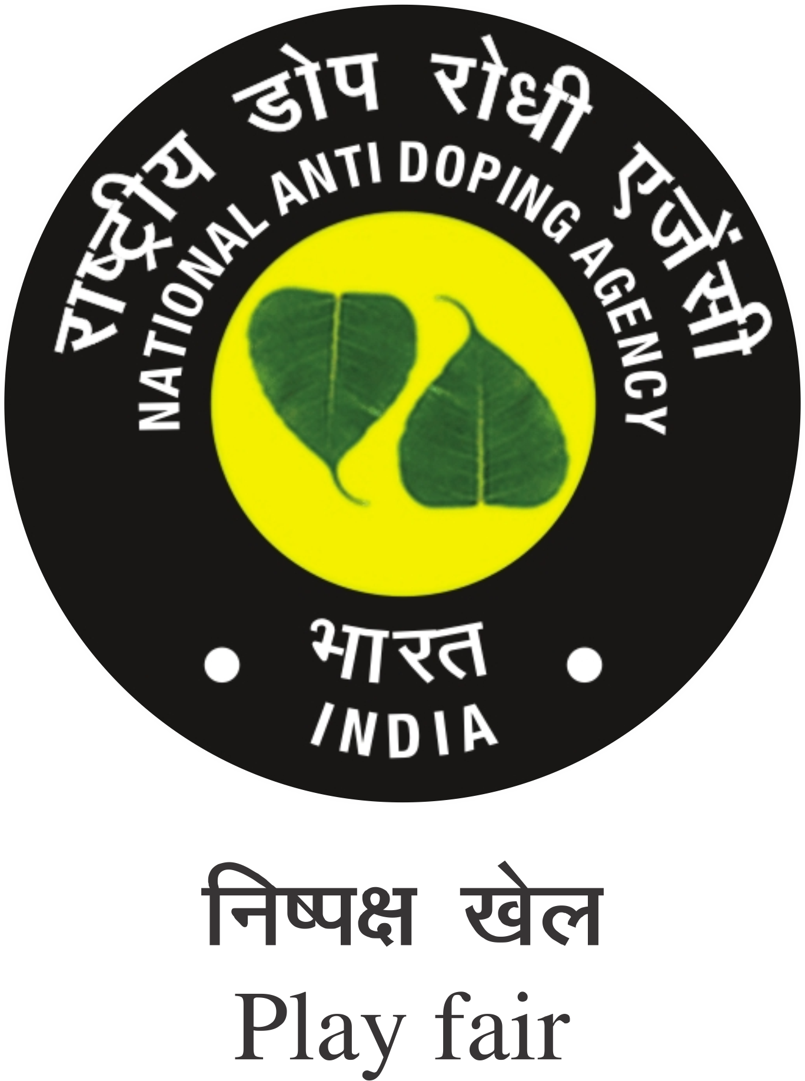 राष्ट्रीय डोप-रोधी एजेंसी
Anti-Doping Education & Awareness Sessions Educator Tour Report
S.No. | Particulars | Details | Remarks
 | Date of Session
 | Name of Session
 | IN/OC Competition
 | Sports Discipline
 | Location
Target group

- International-Level Athletes
- National –Level Athletes
- Young & Budding Athletes
- Talented Athletes
- School Sports Students
- RTP Athletes
- Athletes Support Personnel
- Athletes Serving Ineligibility
- Athletes with Disability

 | Mode of Education
 | Total No of Participants attended
 | Total No. of Athlete attended
 | Total No. of ASPs attended.
 | Photos
 | Total no of Feedback taken
 | Total no of Questionnaire/ Assessment taken
 | Remark
National Anti-Doping Agency, India

Name & Signature of the Educator
Verified by NADA Official

